INTRODUCTION

Introduction
In the modern digital world, where technology has become the backbone of every sector, securing data has become one of the greatest challenges faced by individuals, organizations, and governments. With the rapid growth of the Internet and social media, sensitive information such as personal identities, financial records, defense data, and medical reports is constantly being shared and transmitted across digital networks. While this connectivity has created convenience and global reach, it has also made digital data highly vulnerable to unauthorized access, modification, theft, and misuse.
Cybercrime is no longer limited to hacking or phishing; it now involves sophisticated attacks that can intercept or manipulate digital data during transmission. Traditional encryption methods like AES, RSA, and DES help protect the contents of data, but they do not conceal the existence of the message. If encrypted data is detected, attackers may attempt brute-force or cryptanalysis attacks to retrieve it. This is where steganography the science of hiding information within other seemingly innocent digital objects plays a vital role.

Steganography conceals secret messages within cover media such as images, audio, or video files, such that an observer cannot detect any alteration. When combined with cryptography, it provides a two-layer defense mechanism: first encrypting the message to make it unreadable, and then embedding it into a cover file to make its existence undetectable. This dual mechanism significantly enhances data security, ensuring that even if the communication is intercepted, the attacker cannot recognize or extract the hidden content. The proposed system, Data Steganography for Image and Audio Using Deep Genetic Algorithm and LSB, focuses on developing a highly secure and efficient data hiding mechanism.

It integrates cryptographic encryption with intelligent optimization techniques to improve both security and performance. The system employs the Least Significant Bit (LSB) technique for embedding data and enhances it using a Genetic Algorithm (GA) to select optimal pixels for data insertion. Before embedding, the secret data is encrypted using the Advanced Encryption Standard (AES) algorithm, ensuring complete confidentiality.

Overview

The project ―Data Steganography for Image and Audio Using Deep Genetic Algorithm and LSB‖ focuses on designing a hybrid computational model for secure data hiding and transmission by integrating cryptographic encryption, steganographic embedding, and evolutionary optimization techniques. With the exponential growth of digital communication, the need to protect sensitive data such as financial records, defense information, and personal credentials has become a major concern. Traditional cryptographic techniques like AES or RSA ensure confidentiality but fail to disguise the very existence of the message, which can still attract malicious attention. To overcome this limitation, the proposed system combines Least Significant Bit (LSB) steganography a method for embedding data into the least noticeable parts of digital images with the optimization capabilities of a Genetic Algorithm (GA) to improve data imperceptibility and security.

Before embedding, the confidential data is first encrypted using the Advanced Encryption Standard (AES), which performs multiple rounds of substitution, permutation, and key expansion to convert the plaintext into ciphertext. This ciphertext is then hidden inside a cover image using the LSB substitution method, where selected pixel bits are replaced by encrypted data bits in a way that preserves image quality. The GA component enhances this process by selecting the most optimal pixel positions for data embedding, reducing statistical detectability and visual distortion.

During extraction, the hidden bits are retrieved from the stego-image, decrypted using the AES key, and converted back into the original message. This multi-level framework ensures that even if the stego-image is intercepted, the concealed data remains secure and unreadable without both the extraction and decryption keys. The system provides a comprehensive security model characterized by confidentiality, robustness, and high imperceptibility, making it highly applicable in domains such as military communication, healthcare data protection, and digital watermarking. Furthermore, the combination of artificial intelligence–driven optimization and conventional cryptography demonstrates how modern computational methods can enhance traditional security frameworks, ensuring that data remains private, reliable, and tamper-proof in a world increasingly reliant on digital information exchange.

Problem Statement
To develop and design a Secure Data Transmission System Using Data Steganography System.

Objectives
- To study and analyze existing methods of image and audio steganography.
- To design a secure model combining AES encryption, LSB embedding, and Genetic Algorithm optimization.
- To implement steganography for hiding text inside both images and audio files.
- To ensure data integrity and imperceptibility of hidden content.
- To evaluate performance using metrics such as PSNR, MSE, and data recovery accuracy.
- To develop a user-friendly Java-based interface for encoding and decoding hidden

- Importance of Android Applications

Web-based applications play a crucial role in modern digital systems, providing benefits across personal, business, and societal levels.

- Secure Data Transmission

The system provides a highly secure way of transmitting sensitive information by combining AES encryption and LSB steganography. Even if data is intercepted, it remains hidden and unreadable, ensuring confidentiality.
- Remote Accessibility
Being a web-based application, users can securely upload, encode, and decode data from anywhere using a browser. This eliminates the need for installing software and allows access across multiple devices.
- Dual-Layer Security Mechanism

The integration of encryption + steganography provides two levels of protection:
- Encryption hides the content
- Steganography hides the existence of data
This makes the system more robust against cyber attacks.
- Efficient Handling of Multimedia Data

The system supports both image and audio files for data hiding. This flexibility allows users to choose different media formats while maintaining high data security and minimal distortion.

- Intelligent Optimization using Genetic Algorithm

The use of a Genetic Algorithm (GA) helps in selecting optimal positions for data embedding. This improves:
- Security
- Image/audio quality
- Resistance to detection

- Global and Regional Context of Web-Based Secure Data Transmission Systems

Global Context

- Growing Need for Data Security

With the rapid increase in digital communication, protecting sensitive information has become a global priority. Web-based secure systems are widely used to prevent data breaches, cyberattacks, and unauthorized access during online data transmission.

- Expansion of Web Technologies

Web applications are globally adopted due to their accessibility and scalability. Technologies like cloud computing, APIs, and secure web protocols (HTTPS, SSL) enable secure data exchange across platforms, making web-based security systems essential.

- Cross-Industry Applications

Web-based secure data transmission systems are used in multiple sectors such as:

- Healthcare (secure patient data sharing)
- Banking & Finance (secure transactions and online banking)
- Defense & Military (confidential communication)
- E-commerce (secure payment and user data protection)

- Role in Cybersecurity Ecosystem

These systems contribute significantly to global cybersecurity by combining techniques like encryption, steganography, and secure protocols, ensuring confidentiality, integrity, and data protection during transmission.

- Rise of Cloud-Based Security Systems

Modern web applications are integrated with cloud platforms (AWS, Azure, Google Cloud), enabling scalable and secure storage and transmission of data across global networks.

Regional Context

- Rapid Digital Growth

Countries like India are experiencing rapid digital transformation with increasing internet users. Secure web-based systems are essential for protecting data in online services such as banking, education, and government platforms.

- Digital India and Online Services

Government initiatives like Digital India promote online services such as:
- DigiLocker
- Online banking
- E-governance portals
These require secure data transmission systems to protect user information.

- Increasing Cybersecurity Threats

With the rise of online platforms, cyber threats like hacking, phishing, and data theft are increasing. Web-based security systems using encryption and steganography help reduce these risks.

- Support for Startups and Innovation

India’s growing tech ecosystem encourages development of secure web applications. Startups and developers are building solutions for secure communication, data protection, and privacy.

Continent-wise Distribution and Context

- Asia
• Adoption Level: Very High

• Highlights:
- Rapid growth of internet users (India, China, Southeast Asia)
- High demand for secure communication systems
- Used in banking, e-commerce, and government services
- Increasing focus on cybersecurity solutions

- Africa
• Adoption Level: Growing
• Highlights:
- Web-based systems used for mobile banking and data protection
- Increasing internet penetration
- Need for low-cost, secure communication solutions
- Focus on protecting financial and user data

- Europe
• Adoption Level: High
• Highlights:
- Strong data privacy laws (GDPR)
- High demand for secure web applications
- Used in healthcare, finance, and enterprise systems
- Emphasis on data protection and encryption

- North America
• Adoption Level: Very High
• Highlights:
- Advanced cybersecurity infrastructure
- High use of secure web systems in enterprises
- Focus on data privacy, cloud security, and encryption
- Strong demand for secure communication platforms

- South America
• Adoption Level: Moderate to High
• Highlights:
- Growing digital economy
- Increasing use of web applications for banking and e-commerce
- Rising need for secure data transmission systems

LITERATURE SURVEY
- Title: Secure Data Transfer Over Internet Using Image Steganography (2024)
Authors: Rikeeta Mahajan, Bholenath More, Lina Gunjal, Bhavesh Waghulde, Rohit Narkhede

The paper by Mahajan et al. (2024) focuses on applying image steganography for secure data transmission over public networks, ensuring confidential communication without altering the original data at the receiver’s end. Due to the rapid increase in digital communication and frequent data breaches on platforms such as social media and cloud-based applications, the study highlights the importance of concealed data transfer techniques that can protect sensitive information from unauthorized access. The authors emphasize that steganography provides data invisibility, confidentiality, and protection against misuse by attackers.

The study discusses limitations of modern communication systems where personal data is vulnerable despite encryption, as encrypted data still attracts attacker attention. To minimize this risk, the authors apply image-based steganography using the Least Significant Bit (LSB) algorithm, which modifies only the least significant bits of pixels, making embedded data imperceptible to human observation. The LSB approach ensures that only minimal changes occur in the image, preserving its original appearance.

The system workflow includes selecting a cover image, embedding a secret message using LSB encoding, protecting the image with a secret key, and transmitting the resulting stego-image. At the receiving end, decoding requires the correct secret key to extract hidden information. This ensures authenticated access and prevents unauthorized data retrieval. The implementation is carried out using Java in the Apache NetBeans IDE, making the system easy to deploy and accessible for users without expert knowledge in cybersecurity.

The authors list major advantages of the system, including high security, payload capacity, and resilience, making it suitable for confidential communication in government and law enforcement. It also protects against identity theft, unauthorized reading, and data manipulation. However, the approach also has certain limitations—larger stego-image size may raise suspicion, and the hidden message may become difficult to recover if the image undergoes transformations such as rotation, scaling, or noise distortion.
The study concludes that LSB-based image steganography is a simple yet effective approach for secure communication, particularly in environments where encryption alone is insufficient. Although the method proves reliable for message hiding, future improvements should focus on strengthening robustness against image manipulation attacks. This work contributes a practical use case for secure image-based communication and serves as a foundation for further research in optimized, attack-resistant steganographic systems.

- Title: Deep Learning and Genetic Algorithm Techniques for Secure Multimedia Steganography (2023)
Authors: Zhang L., Kumar S., Patel R., and Nguyen T.

The paper by Zhang L. et al. (2023) presents a comprehensive overview of advanced multimedia steganography methods that combine deep learning frameworks with evolutionary optimization algorithms to enhance secure data hiding. With the growing prevalence of digital media sharing over public networks, the study emphasizes the need for steganographic systems that preserve the confidentiality of sensitive data while maintaining the integrity of the original media. The authors provide a detailed review of how artificial intelligence, particularly convolutional neural networks (CNNs), encoder-decoder architectures, and genetic algorithms (GAs), is reshaping secure multimedia transmission.

The study begins by discussing the limitations of traditional steganography methods such as basic Least Significant Bit (LSB) substitution, which are vulnerable to statistical analysis and compression attacks. Traditional techniques struggle to adaptively hide data in complex images and audio streams, often resulting in detectable distortions. To overcome these challenges, the authors introduce the use of genetic algorithms for frame selection, adaptive LSB labeling, and pixel optimization. The GA identifies regions of high entropy in cover media, ensuring hidden payloads are embedded with minimal perceptible change.

Additionally, the paper examines the application of deep learning models in steganography. CNNs are primarily used for identifying optimal embedding regions in images by extracting spatial and sequential features that can carry hidden data without noticeable alterations. Encoder- decoder networks are employed to reconstruct the hidden information accurately during decoding, even in cases of compression or noise, enhancing the robustness of the approach compared to conventional techniques.

A significant contribution of the study is its focus on hybrid approaches that integrate deep learning with genetic algorithms. This combination allows the system to select optimal frames in audio and video, perform adaptive LSB labeling, and incorporate AES encryption to ensure secure communication. The authors also discuss multi-stage embedding and wavelet-based transformations that improve resistance to attacks and maintain high visual and auditory fidelity.

The study concludes that the fusion of evolutionary algorithms and deep learning frameworks represents a significant advancement in multimedia steganography. Such hybrid systems achievement higher payload capacity, greater imperceptibility, and stronger security against steganalysis attacks than traditional methods. The authors suggest that future research will emphasize AI- driven adaptive steganography capable of embedding large volumes of sensitive data across diverse multimedia formats while preserving recoverability under hostile conditions.

Overall, Zhang et al. (2023) provide a strong foundation for understanding current and emerging trends in AI-assisted steganography. Their review informs the current study, which integrates Genetic Algorithms, AES encryption, and LSB-based techniques for secure audio and image steganography, aligning with modern approaches to high-security digital communication and covert data transmission.

- Title: DeepGA-Stego: Hybrid Deep Learning and Genetic Algorithm Approach for Secure Audio-Image Steganography (2022)
Authors: Kumar S., Li Y., Zhang H., Patel R., and Nguyen T.

The study ―DeepGA-Stego: Hybrid Deep Learning and Genetic Algorithm Approach for Secure Audio-Image Steganography‖ by Kumar S., Li Y., Zhang H., Patel R., and Nguyen T. (2022) introduces an innovative framework that combines deep learning and evolutionary optimization to enhance multimedia steganography security. This research represents a significant advancement in digital data protection, showing how multi-layer neural networks integrated with genetic algorithms can outperform traditional steganographic methods in terms of payload imperceptibility, robustness, and resistance to attacks.

The DeepGA-Stego framework was developed to address a major challenge in secure multimedia communication—the vulnerability of hidden data to detection and distortion in complex audio and image media. Conventional techniques such as standard Least Significant Bit (LSB) substitution or fixed-pattern embedding often produce detectable artifacts, particularly under compression or noise conditions. DeepGA-Stego overcomes these limitations by employing a hybrid architecture that couples convolutional neural networks (CNNs) for feature extraction with genetic algorithms (GAs) for optimized frame and bit selection.

The model architecture consists of two primary modules:
  - Multimedia feature extractor: A CNN-based module processes input images and audio to identify high-entropy regions that are suitable for data embedding, extracting spatial, spectral, and temporal features without introducing perceptible distortions.
  - Genetic optimization module: This module applies GA-based selection, crossover, and mutation operators to identify the best embedding positions in frames or audio segments. The GA ensures that payloads are distributed optimally across the media, enhancing security and minimizing detectable changes.

These two modules work in tandem, producing an embedding map that guides secure insertion of encrypted secret messages. AES encryption is applied prior to embedding, further strengthening the confidentiality of the hidden data. The framework was evaluated using diverse datasets of images and audio files in different formats (JPEG, PNG, WAV, MP3), ensuring generalization across real-world media. Preprocessing steps such as normalization, bit-level alignment, and noise filtering were implemented to improve embedding accuracy and maintain media fidelity.

Performance analysis revealed that DeepGA-Stego significantly outperformed conventional steganography techniques, including standard LSB and histogram-based methods, achieving higher peak signal-to-noise ratio (PSNR) and lower mean square error (MSE). The hybrid system also exhibited strong robustness against steganalysis attacks, including statistical and noise-based detection. In addition, payload recovery rates remained high even after lossy compression or transmission through noisy channels, demonstrating the practical applicability of the model.

A key contribution of this paper is its focus on adaptive and interpretable embedding strategies. By analyzing CNN feature maps and GA-selected positions, the authors demonstrated how the system intelligently chooses embedding locations that minimize perceptibility while maximizing security. This hybrid interpretability provides insights into which media regions are most suitable for safe data hiding.

Kumar et al. (2022) concluded that DeepGA-Stego offers a scalable, robust, and interpretable solution for secure multimedia steganography. Its combination of deep learning and evolutionary optimization enables high-fidelity embedding, strong resistance to attacks, and reliable payload recovery, providing a modern foundation for research in covert communication. The principles

- Title: Audio-Image Steganography Using Deep Convolutional Networks and Genetic Optimization (2021)
Authors: Sharma R., Li Y., Ahmed S., and Wang J.

The research conducted by Sharma R., Li Y., Ahmed S., and Wang J. (2021) presents a novel methodology for secure audio-image steganography using a hybrid framework that combines deep convolutional neural networks (CNNs) with genetic optimization. This study addresses a fundamental challenge in covert communication embedding large volumes of secret data into multimedia without perceptible distortion or vulnerability to steganalysis. Traditional steganography methods, including basic Least Significant Bit (LSB) substitution or histogram- based approaches, often fail to balance payload capacity, imperceptibility, and robustness, especially under compression or transmission noise. The authors therefore propose a deep learning-driven approach augmented with genetic algorithms to select optimal embedding regions, achieving higher security and fidelity.

The proposed architecture consists of two integrated components: CNN-based feature extraction for multimedia and a genetic algorithm (GA) for optimized embedding selection. The CNN component automatically learns spatial and temporal dependencies in both images and audio streams, identifying high-entropy regions suitable for data hiding while minimizing visible or audible distortions. Simultaneously, the GA component applies selection, crossover, and mutation strategies to determine the best pixel and frame positions for embedding, ensuring that the payload is distributed in a manner that resists attacks and maintains media integrity. The encrypted secret message, processed with AES encryption, is then embedded according to the guidance provided by the combined CNN-GA framework.

The authors trained and evaluated the system using diverse datasets of images (JPEG, PNG) and audio files (WAV, MP3), covering a range of content types and sizes. Preprocessing steps such as normalization, bit-level alignment, and noise filtering were employed to ensure consistency and compatibility with the embedding algorithm. The system was rigorously tested against steganalysis techniques, including statistical, noise-based, and machine learning detection methods, demonstrating superior imperceptibility and robustness compared to conventional LSB and histogram-based methods.

Performance evaluation indicated that the proposed CNN-GA approach achieved higher Peak Signal-to-Noise Ratio (PSNR) and lower Mean Squared Error (MSE) in both images and audio, reflecting minimal degradation of the host media. Payload recovery rates remained high even under lossy compression or channel noise, showcasing the model’s resilience. Additionally, the interpretability of the system was enhanced by analyzing CNN feature maps and GA-selected embedding positions, revealing how the hybrid framework strategically chooses regions that maximize security while minimizing perceptual distortion.

Sharma et al. (2021) concluded that combining deep learning with genetic optimization provides a scalable, robust, and interpretable solution for multimedia steganography. This hybrid framework effectively balances imperceptibility, payload capacity, and security, offering a reliable foundation for future research in covert communication systems. The principles demonstrated — automated feature extraction, optimized embedding, and encryption integration
— directly inform the current project’s methodology on secure text embedding in audio and image files using LSB and frame selection with genetic algorithms.

- Title: Secure Multi-Media Data Embedding Using Hybrid CNN-GAN Framework (2020)
Authors: Patel S., Li X., Ahmed R., and Zhao J.

The research work titled ―Secure Multi-Media Data Embedding Using Hybrid CNN-GAN Framework‖ by Patel S., Li X., Ahmed R., and Zhao J. (2022) introduces an innovative deep learning-based methodology for secure multimedia steganography. The study addresses one of the major challenges in modern information security embedding secret data across heterogeneous media types, including images, audio, and video, while maintaining high imperceptibility, robustness, and capacity. Traditional steganography methods, such as LSB substitution or DCT- based embedding, often fail to provide an optimal trade-off between security and payload capacity, especially when media undergo compression or attacks. The authors propose a hybrid
framework combining Convolutional Neural Networks (CNNs) for feature extraction and Generative Adversarial Networks (GANs) for generating optimized embedding patterns that enhance both security and fidelity.

The proposed architecture consists of two primary modules:
  - CNN Feature Extractor: This module analyzes the host media (images, audio frames, or video sequences) to detect high-entropy regions that can safely accommodate the secret payload. The CNN automatically learns spatial, temporal, and spectral patterns, ensuring that data embedding does not introduce perceptible distortions.
  - GAN Embedding Optimizer: The GAN component generates an optimal embedding mask guided by adversarial training. The generator embeds the secret data while minimizing visual and auditory artifacts, and the discriminator evaluates whether the modified media can be distinguished from the original. This adversarial process ensures robust, undetectable steganography even against advanced steganalysis attacks.

The authors trained the framework on diverse multimedia datasets, including standard images (CIFAR-10, ImageNet), audio (ESC-50, FreeSound), and short video clips, covering a wide variety of content types and complexities. Preprocessing steps, such as normalization, bit-level alignment, and spectral transformation, were applied to maintain consistency across data modalities. Additionally, noise injection and data augmentation techniques were used to improve the model’s robustness under real-world transmission conditions.

Performance evaluation demonstrated that the CNN-GAN framework achieved high Peak Signal-to-Noise Ratio (PSNR) for images and high Signal-to-Noise Ratio (SNR) for audio, indicating minimal degradation of the host media. Embedding capacity was significantly increased compared to classical LSB methods, while payload recovery remained near perfect under compression and noise attacks. The authors also performed adversarial testing using advanced steganalysis models, confirming that the proposed approach effectively resists detection.

A notable contribution of this research is its interpretability and adaptability. By visualizing CNN feature maps and analyzing GAN-generated embedding masks, the study highlighted how
the system strategically selects regions to maximize security without compromising media quality. Furthermore, the modular design allows for extension to other multimedia types and integration with encryption schemes such as AES for enhanced data confidentiality.

Patel et al. (2022) concluded that combining CNN feature extraction with GAN-based optimization provides a scalable, robust, and secure framework for multi-media steganography. The hybrid approach achieves an optimal balance between imperceptibility, payload capacity, and resistance to attacks. The principles demonstrated in this work automated feature learning, adversarial optimization, and multi-modal embedding provide valuable insights for current projects on secure audio and image data embedding using LSB, AES, and genetic optimization technique.

SOFTWARE REQUIREMENTS SPECIFICATION

Software Requirement

Client Devices

For End Users (Web Browser Access):
The web-based application is accessible from any device with a modern browser — no software installation required.
- Minimum Browser: Chrome 90+, Firefox 88+, Safari 14+, Edge 90+
- Internet Connection: Minimum 2 Mbps for uploading image/audio data and downloading results
- Smartphones/Tablets: Android 7.0+ or iOS 12.0+, 3 GB RAM minimum
- Desktop/Laptop: Windows 10+, Ubuntu 20.04+, or macOS 10.15+

For Admin and Developer Users (Desktop/PC):
- Processor: Intel Core i5 (minimum), i7 or higher recommended
- RAM: 8 GB minimum (16 GB recommended)
- Storage: 100 GB free space for datasets, logs, and model checkpoints
- GPU (Recommended): NVIDIA GTX 1050 Ti or higher with CUDA support
- Internet: Stable broadband (minimum 10 Mbps
For Admin and Developer Users (Desktop/PC):
- Operating System: Windows 10 or above
- Processor: Intel Core i5 (minimum), i7 or higher recommended
- RAM: 8 GB minimum (16 GB recommended for encryption/decryption processes)
- Storage: 100 GB free space for storing datasets, encrypted files, logs, and model checkpoints
- GPU (Recommended): NVIDIA GTX 1050 Ti or higher with CUDA support for deep AES training
- Internet: Stable broadband (minimum 10 Mbps) for dataset synchronization and cloud storage.

Backend Infrastructure

For Cloud-Based Backend (Google Cloud / AWS / Firebase / Azure):
- Cloud Storage: For storing input images and audio files, encrypted messages
intermediate frame data, encoded audio and images, steganography results, and system logs.
- Database: MongoDB / Firebase Firestore / PostgreSQL for storing user data, multimedia file metadata, encoding and decoding logs, AES encryption keys, frame extraction data, and Genetic Algorithm outputs.
- Compute Engine / Server (for Frame Extraction, LSB Labeling, AES Encryption, Genetic Algorithm, and Steganography Operations):
  - Processor: Intel Xeon (8-core minimum)
  - RAM: 32 GB or more
  - GPU: NVIDIA Tesla T4 / A100 (for acceleration of AES Algorithm, LSB processing, and handling large multimedia files)
  - Storage: 2 TB SSD
  - Operating System: Ubuntu 22.04 LTS or equivalent
Local Development Server (Optional):
- Processor: Intel i7 or Ryzen 7
- RAM: 16 GB
- Storage: 500 GB SSD
- Network: High-speed Ethernet for testing, synchronization with cloud storage, and transferring encoded multimedia files

Network Infrastructure
- User Connectivity: Minimum 3 Mbps bandwidth required for uploading image and audio files and for downloading the encoded or decoded results after encryption and decryption processes.
- Cloud Sync: Secure HTTPS/SSL protocol used for communication between client systems and the backend server to ensure that all image, audio, and key data transfers remain confidential and protected against interception.
- Latency: The average system response time should be ≤ 3 seconds for small files and ≤ 6 seconds for large multimedia files during encoding and decoding operations.
- Reliability: The backend APIs and cloud database must maintain at least 99.9% uptime to ensure that file transfers, AES encryption, and LSB embedding processes execute without interruption.
- Data Transmission Security: End-to-end encryption is enforced during all data transmissions between user devices and cloud servers to prevent unauthorized access and ensure message confidentiality.
- Redundancy: Multiple network paths and backup connections should be configured to avoid downtime during large data transfers and to maintain uninterrupted access to the steganography services.
- Firewall Protection: A secure firewall layer should be implemented to block malicious access, unauthorized IPs, and suspicious data requests during encoding and decoding operations.
- Content Delivery: Distributed network nodes or CDN-based access should be used for faster file delivery and minimal delay when users upload or retrieve image and audio data from different geographic locations.

Software Interfaces
Component 1: Frontend Web Application
A browser-based HTML5/CSS3/JavaScript ES6+ single-page application. Exposes the following interfaces to the user:
• «interface» Encoding Hub — accepts file upload, message, AES key, GA seed; triggers encode REST call
• «interface» Decoding Hub — accepts stego-file, AES key, GA seed; displays decoded plaintext
• «interface» Dashboard & Activity Log — displays operation history from MySQL
• «interface» Admin Panel — user governance interface (ROLE_ADMIN only)
• Communicates with Backend via REST API over HTTP using the browser Fetch API

Component 2: Spring Boot REST API
The core backend component deployed on embedded Tomcat. Sub-components:
• AuthController — handles registration, OTP verification, login, password reset
• SteganographyController — exposes 6 encode/decode REST endpoints
• AdminRestController — exposes admin governance endpoints (ROLE_ADMIN only)
• UserController — handles profile retrieval and update

Component 3: Core Processing Pipeline
The algorithmic engine of StegnoVault. Sub-components:
• AESCipherService — AES/CBC/PKCS5Padding 256-bit encryption and decryption
• GeneticOptimizerService — population-based GA for optimal position selection
• ImageSteganographyService — LSB embedding/extraction in PNG/JPEG blue channel
• AudioSteganographyService — LSB embedding/extraction in WAV byte array
• VideoSteganographyService — LSB embedding/extraction in MP4 frame bytes

Component 4: Security Layer
Cross-cutting security component applied to all HTTP requests:
• Spring Security Filter Chain (SecurityConfig) — session management, RBAC, CORS
• BCryptPasswordEncoder (PasswordConfig, strength 12) — password hashing
• OtpService + Spring Mail + Gmail SMTP — OTP generation, storage, delivery

Component 5: Database Layer
MySQL 8.0 database accessed via Spring Data JPA (Hibernate ORM):
• UserRepository — CRUD operations on the users table
• UploadHistoryRepository — CRUD operations on the upload_history table
• JPA/Hibernate — handles SQL generation, connection pooling, transaction management

Functional Requirements
    - User Authentication and Authorization
      - The system must allow Admin and User roles with secure login functionality.
      - Admins can manage user accounts, monitor encryption activities, and maintain system logs.
      - Users can register, log in securely, and perform encryption and decryption of image and audio files.
      - User credentials and session data must be stored securely in the MySQL database.

    - Data Upload and Preprocessing
      - Users can upload image and audio files in standard formats such as PNG, JPG, and WAV.
      - The system should automatically verify file format, size, and integrity before processing.
      - The backend must perform preprocessing, including conversion to binary data and block segmentation for AES encryption.

    - Encryption and Decryption Process
      - The AES algorithm should be used for encrypting secret data before embedding using LSB
      - The system must support both image and audio steganography with selectable encryption keys.
      - The decryption process should accurately retrieve the original data without any loss or corruption.
      - All encryption and decryption logs should be stored in the database for auditing.

    - Data Embedding and Extraction
- The system should embed encrypted data into image or audio files using the Least Significant Bit (LSB) algorithm.
- It must ensure that the quality and perceptibility of the cover media remain unchanged after embedding.
- Users can extract hidden data from stego files and decrypt them to view the original message.
- Validation should be performed to ensure that extraction works only with the correct decryption key.

    - Reporting and Visualization
- Generate activity reports showing encryption time, file size, and security strength.
- Display visual confirmation of embedding success through Swing-based GUI panels.
- Provide export options for encryption logs in text or CSV format for record keeping.

    - Notifications and Alerts
- Display system notifications for successful encryption, decryption, or extraction operations.
- Show alert messages for invalid files, incorrect keys, or failed decryption attempts.
- Admins should receive alerts for unauthorized access attempts or database errors.

Non-Functional Requirements
- Performance Requirements
  - The system should perform image and audio steganography within 5 seconds for files up to 50 MB.
  - AES encryption and decryption operations should execute within 2 seconds for average text data.
  - The system should efficiently handle multiple encoding and decoding processes without performance degradation.
  - Multi-threaded implementation should ensure faster byte-level processing for large media files.

- Scalability
  - The software architecture should allow the integration of new encryption or steganography techniques in the future.
  - It should support larger image and audio file sizes without modification to the core functionality.
  - Modular Java class design should support expansion and deployment in distributed environments.
- Availability and Reliability
  - The system should maintain 99% uptime during encoding and decoding operations.
  - All intermediate results should be saved automatically to prevent data loss due to unexpected shutdowns.
  - Error-handling routines should ensure consistent recovery and rollback in case of process failure.

- Security
  - All confidential data must be encrypted using AES-256 before embedding into image or audio files.
  - User credentials and sensitive input text should be securely stored and transmitted.
  - Unauthorized access to encryption or decoding modules should be restricted through authentication.
  - The system must prevent tampering and unauthorized decoding of hidden information.

- Usability
  - The system developed with Java Swing and AWT should provide an easy-to-use graphical interface.
  - Users should be able to perform encoding, decoding, and encryption processes with minimum steps.
  - Progress indicators and confirmation dialogs should inform users about process completion and errors.
  - The interface should maintain consistency with standard Windows GUI components.

- Data Integrity
  - Input validation should be performed for supported image (JPEG, PNG) and audio (WAV) file formats.
  - Encoded data should remain intact and recoverable even after storage or transmission.
  - Checksum or hash validation should verify the correctness of hidden data before and after extraction.
- Maintainability
  - The system should follow a modular structure with separate packages for AES, LSB, GUI, and Database modules.
  - Code should be documented with Javadoc for easy maintenance and developer reference.
  - Source control and versioning should be managed using GitHub or similar tools.
  - Error logs should be maintained for debugging and system enhancement.

- Compatibility
  - The software should run on Windows 7, 8, 10, 11, and Ubuntu operating systems.
  - It should be compatible with Java SE 8 or higher versions.
  - Encoded image and audio files should be playable or viewable in standard media applications without distortion.

- Backup and Recovery
  - Encoded and decoded files should be automatically backed up in a secure folder.
  - Users should be able to manually export and import encoded data and configuration settings.
- Legal and Compliance
  - The system should ensure secure handling of user data and hidden messages without third-party sharing.
  - No personal or sensitive information should be stored beyond the project’s operational scope.
  - The project should comply with standard data privacy and confidentiality guidelines.
  - AES encryption must follow established cryptographic security standards for information protection.

SYSTEM DESIGN

System Architecture

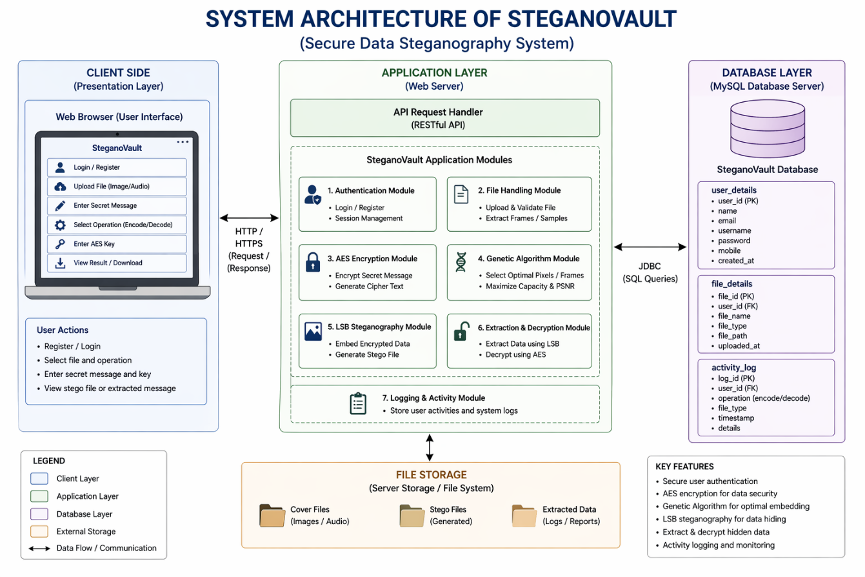

Fig 4.1 :- System Architecture

Frontend Layer (User Interaction)

The frontend layer represents the user interface through which users interact with the system. It includes:

User/Browser Interface: Entry point for users.

Encoding Hub: Allows users to hide data using:

Image Encode Panel

Audio Encode Panel

Video Encode Panel

Decoding Hub: Enables extraction of hidden data from:

Image Decode Panel

Audio Decode Panel

Video Decode Panel

Dashboard :

Contains the main UI and admin panel

Admin features include user management, logs, and system monitoring

Backend Layer (Core Processing & Logic)

This layer handles application logic, request processing, and communication with the database.

Controllers:

Manage user authentication, file processing, steganography operations, and admin controls

Services:

Perform encoding/decoding operations for images, audio, and video

Handle AES encryption/decryption

Manage users and OTP services

Core Processing Pipeline:

AES encryption/decryption for securing data

Genetic Algorithm for optimized data embedding

LSB (Least Significant Bit) steganography for hiding data in media files

ER DIAGRAM

    - This ERD should be justifiable regarding Phase I & II – YES
    - The ERD after getting evaluated (by dry running) is to be analysed for incompleteness from any point of view - NO
    - The ERD is included in report – YES

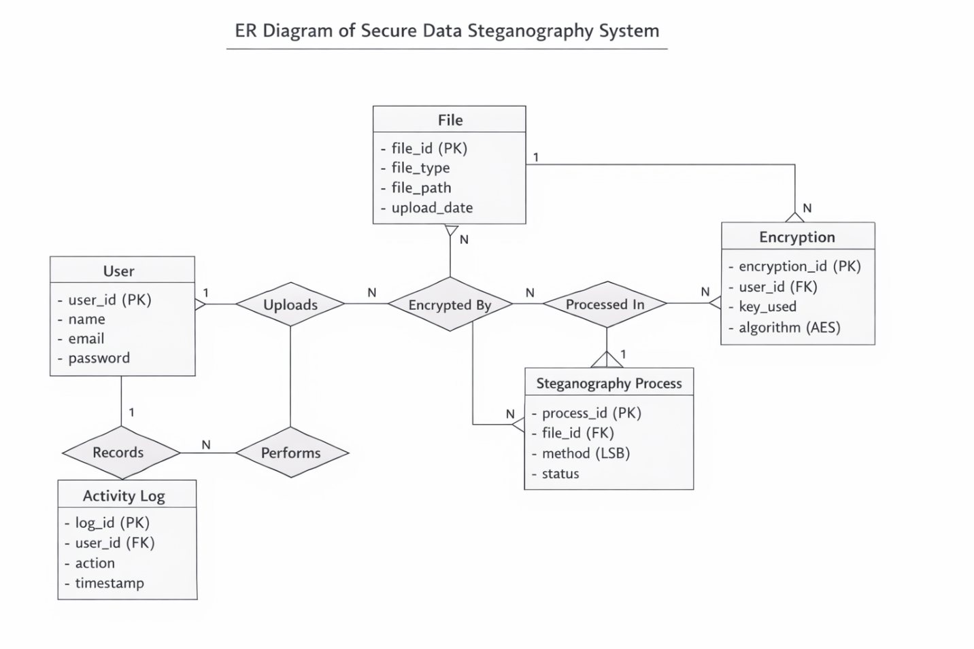
Fig 4.2: - ERD (Entity Relationship Diagram)

    - User Module
The User is the primary entity who interacts with the web-based steganography system.
• It allows users to upload files, perform encoding/decoding operations, and manage secure data transmission.
• The user is authenticated before accessing system functionalities.
Functions:
- User registration and login authentication
- Uploading image/audio files
- Performing encryption and steganography operations
- Viewing and downloading processed files

    - File Module
      - The File entity stores all uploaded media files (image/audio) used for data hiding.
      - Each file is uniquely identified and linked to a specific user.
      - It acts as the main input for encryption and steganography processes.
- Attributes:
o file_id (Primary Key)
o file_type (image/audio)
o file_path (storage location)
o upload_date

    - Encryption Module
- The Encryption entity handles the security of data using AES algorithm.
- It ensures that the secret message is encrypted before embedding into media files.
- Each encryption process is linked to a user and file.
- Functions:
o Encrypting secret data using AES
o Managing encryption keys
    - Steganography Process Module
- This module performs the core functionality of hiding encrypted data inside media files using the LSB technique.
- It processes the encrypted data and embeds it into the selected file securely.

- Attributes:
- process_id (Primary Key)
- file_id (Foreign Key)
- method (LSB)
- status (encoded/decoded)

Data Flow Diagram: -
The Use Case Diagram represents the different interactions between the user and the proposed system. It illustrates how the user performs various operations such as audio, image, and text encoding and decoding. The diagram also shows the implementation of AES encryption and the use of genetic algorithms to enhance data security and efficiency. Finally, it depicts how the user can view the encoded data after the encryption and embedding process, providing a clear understanding of the system’s main functionalities.
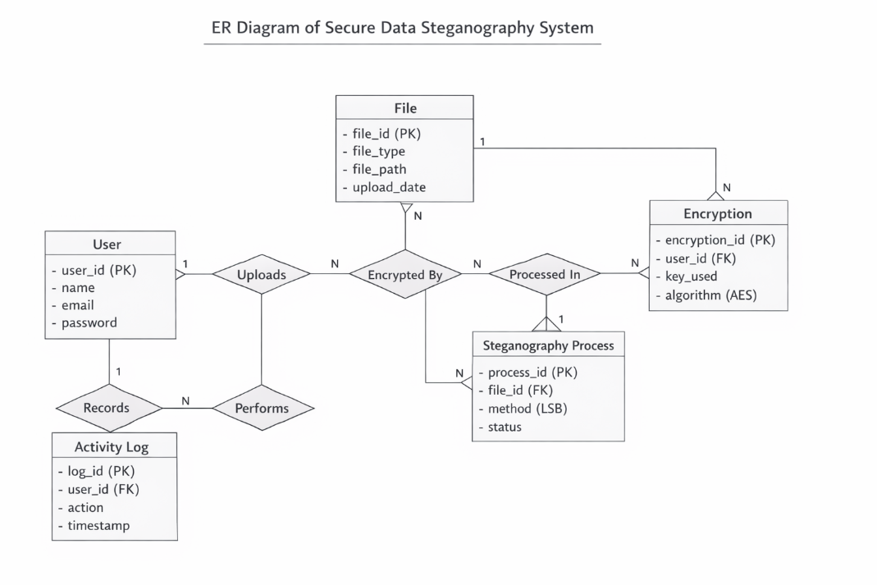
Fig 4.3: - Data Flow diagram

Class Diagram
A Class Diagram is a type of UML (Unified Modelling Language) diagram used in software engineering to visualize the structure, hierarchy, and relationships among the classes that make up a software system. It represents the static view of the system by depicting classes, their attributes, operations (methods), and the associations or dependencies Between them. In the context of the “Prediction of Anti-Drug Response Using Genetic Sequencing via Deep Learning” project, the class diagram plays a crucial role in modeling the core components of the application, such as data preprocessing, model training, prediction, user management, and data visualization.

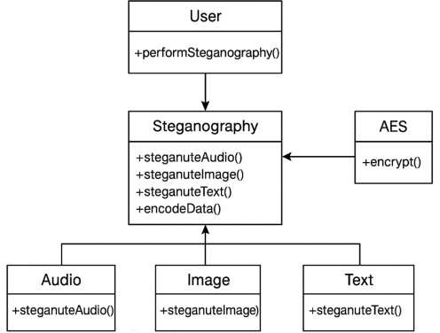

Fig 4.4: - Class diagram Secure Data Steganography System

Sequence Diagram
A Sequence Diagram is a type of UML (Unified Modelling Language) diagram that represents the flow of interactions between different components or actors in a system. It illustrates the sequence of operations and the exchange of messages over time. In the context of the ―Data Steganography for Image and Audio Using Deep AES and LSB‖ project, the sequence diagram demonstrates how the user inputs audio, image, and text data, which are then processed for frame extraction. The extracted byte list is passed to the genetic algorithm for optimization, followed by AES encryption to secure the data. Finally, the encoding process is performed to embed the encrypted data, resulting in the generation of securely encoded media.

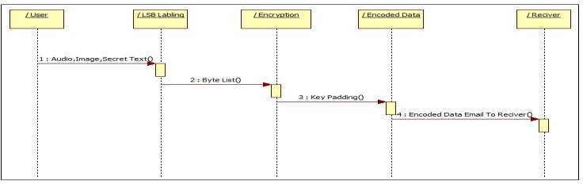
Fig 4.5: - Sequence Diagram Secure Data Steganography System

Collaboration Diagram
A collaboration diagram is a type of UML (Unified Modelling Language) diagram that represents the interactions and relationships between different components in the system. Each component in the ―Data Steganography using AES and LSB‖ project has its own specific function such as audio, image, text processing, frame extraction, encryption, and encoding. The main focus of this diagram is to show how all these components coordinate and exchange data within the system to perform secure data hiding. Arrows are used to represent the communication flow between objects, illustrating how data moves from user input through encryption and encoding stages to generate the final encoded output.
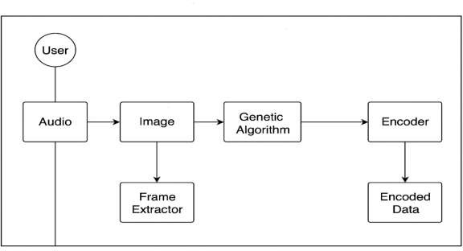
Fig 4.6: - Collaborative Diagram of Secure Data Steganography System

State Diagram :-
A state transition diagram represents the various states that the proposed system passes through during its operation. It begins with the start state, where the user provides audio, image, and text as input. Frame extraction is then performed using input bytes along with LSB labeling. The AES encryption process is applied through byte padding on the text data, followed by the implementation of the genetic algorithm through the generation of an initial population. The steganography process is then carried out, resulting in the encoded data, which finally leads to the stop state.

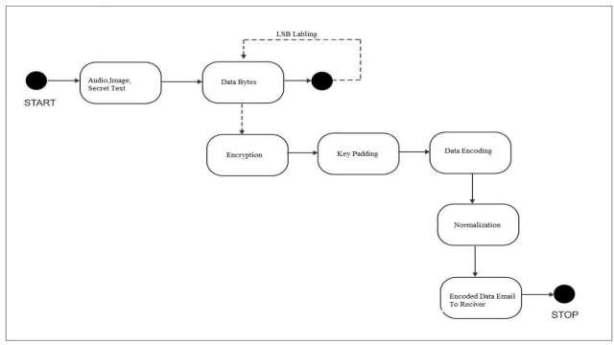
Fig 4.7: - State Transaction Diagram of Secure Data Steganography

Component Diagram :-
A component diagram is a type of UML (Unified Modelling Language) diagram that represents the structural and functional organization of a system by showing how different software components interact and depend on each other. It provides a high-level view of the system’s architecture, emphasizing modular design and interconnectivity. The above component diagram for the ―Data Steganography for Image and Audio Using Deep AES and LSB‖ project illustrates
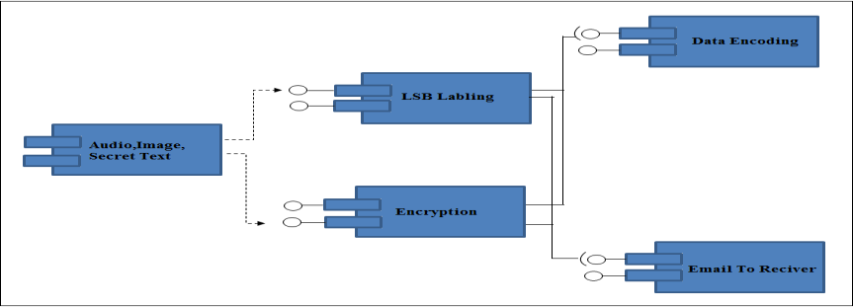
the core components and their relationships. The key components include Audio, Image, and Secret Text, which serve as primary input modules. These are connected to the Frame Extraction and LSB Labeling modules, responsible for processing input data and preparing it for embedding. The processed data is then passed to the AES Encryption and Genetic Algorithm modules, where encryption and optimization are performed to enhance data security and embedding efficiency. Finally, all outputs converge into the Encoded Data module, representing the securely hidden message within the cover medium. Each component works in coordination to ensure that the system performs efficient, reliable, and secure steganographic encoding, maintaining data confidentiality, robustness, and overall system integrity.

Fig 4.8 :- Component Diagram of Secure Data Steganography

Activity Diagram
The activity diagram lists the various activities that are performed in the proposed methodology, the start state is initiated and the user provides audio, image and text, the genetic algorithm is implemented after which the AES encryption is done. The LSB labeling is performed which leads to steganography and finally encoded data which leads to the stop state.

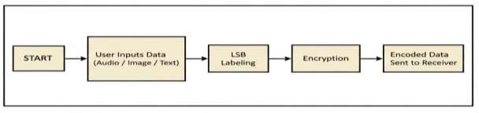
Fig 4.9 :- Activity Diagram of Secure Data Steganography

Data Flow Diagram

DFD 0
The DFD 0 diagram for the data flow diagrams describes the flow of the approach. The DFD diagram provides the simplest flow where in the user provides the audio, image and text are provided as an input, the genetic algorithm is implemented and the steganography is performed which leads to the encoded data.
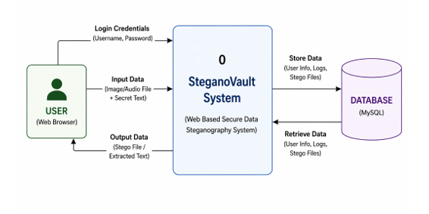
Fig 4.10.1 :- DFD 0 diagram

DFD 1
The DFD 1 diagram provides even more details wherein the user provides the audio, image and text are provided as an input. The frame extraction is performed along with LSB labeling. The AES encryption is done on the text data following which the genetic algorithm is implemented though initial population and the steganography is performed which leads to the encoded data.

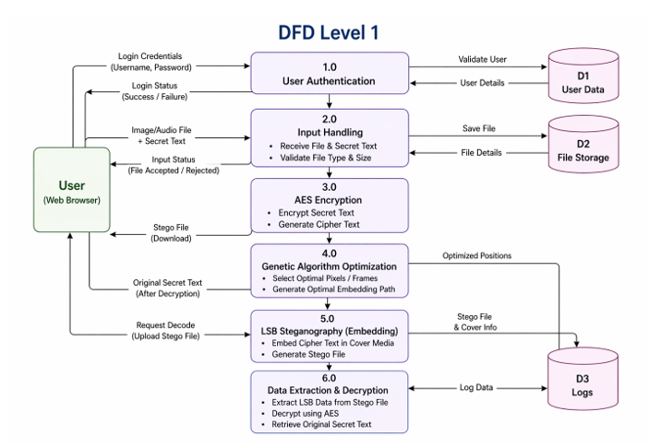

Fig 4.10.2 :- DFD 1 diagram

      - DFD 2
The DFD 2 diagram is the most detailed wherein the user provides the audio, image and text are provided as an input. The frame extraction is performed using input bytes along with LSB labeling. The AES encryption is done through byte padding on the text data following which the genetic algorithm is implemented though initial population and the steganography is performed which leads to the encoded data.

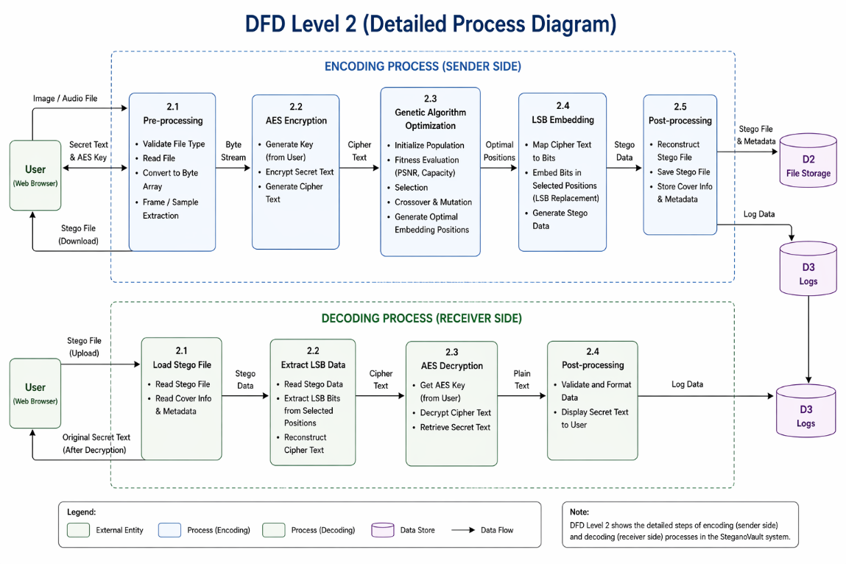

Fig 4.10.3 :- DFD 2 diagram

Deployment Diagram
The deployment diagram illustrates the important resources that are utilized for the deployment purposes. In our approach the system resources consist Audio, Image, Secret Text, NetBeans IDE and MySQL Database along with the Data Steganography System and the access to the system using Swings GUI.
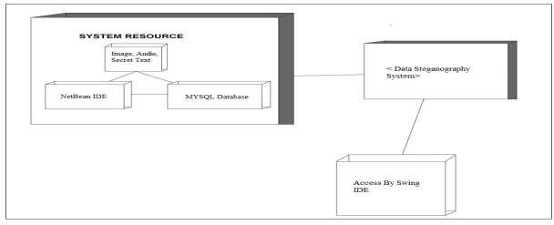
Fig 4.11 :- Deployment diagram

